Lab 12 : Designing Resilient Pipelines: DLQs, Retries & Failure Handling

Table of Contents

Table of Contents 2
Introduction 3
Learning Objectives 3
Prerequisites 4
Retrieve Cloud Credentials 5
Part 1 — Pipeline Setup 8
Step 1 — Create Pipeline Topics 8
Step 2 — Inject Test Messages 8
Part 2 — Consumer/Connector Simulation 10
What’s Happening? 11
Part 3 — Retry Workflow 12
Part 4 — Failure Simulation 13
Scenario 1 — Malformed Messages 13
Scenario 2 — Consumer Crash & Restart 13
Part 5 — Validation 15
Suggested Exercises 16
Knowledge Check 18
Troubleshooting 18
Symptom: No messages consumed 18
Symptom: Authentication Failed / SSL Handshake Error 18
Symptom: Consumer restarts from the beginning every time 18
Next Steps 19
Conclusion 19

Introduction
In real production streaming platforms, pipelines must continue operating even when bad or malformed data arrives. A single invalid record should never crash an entire pipeline.
In this lab, you will design a resilient streaming pipeline using Redpanda Serverless topics and a custom consumer script. You will implement:
- Validation logic
- Retry handling
- Dead Letter Queues (DLQs)
A DLQ is a special topic used to capture messages that cannot be processed successfully after several retries. This allows pipelines to remain operational while isolating problematic records for later inspection.
You will also simulate real operational scenarios:
- Inject malformed events
- Restart consumers mid-stream
- Observe offset recovery behavior
This lab mirrors real-world production requirements where streaming systems must be fault-tolerant and self-healing.

Learning Objectives
After completing this lab, you will be able to:
- Design a resilient multi-topic pipeline in Redpanda Serverless.
- Connect a Python application securely to a cloud-managed cluster.
- Implement retry logic in a streaming consumer.
- Route failed messages into a Dead Letter Queue.
- Simulate malformed data and pipeline failures safely.
- Observe offset management during restarts.

Prerequisites
Before starting, ensure you have:
- rpk installed on your machine.
- Python 3 installed.
- A Redpanda Cloud account (Serverless tier).
Verify your Python environment:
python3 --version

Install the required Kafka Python library:
pip3 install kafka-python

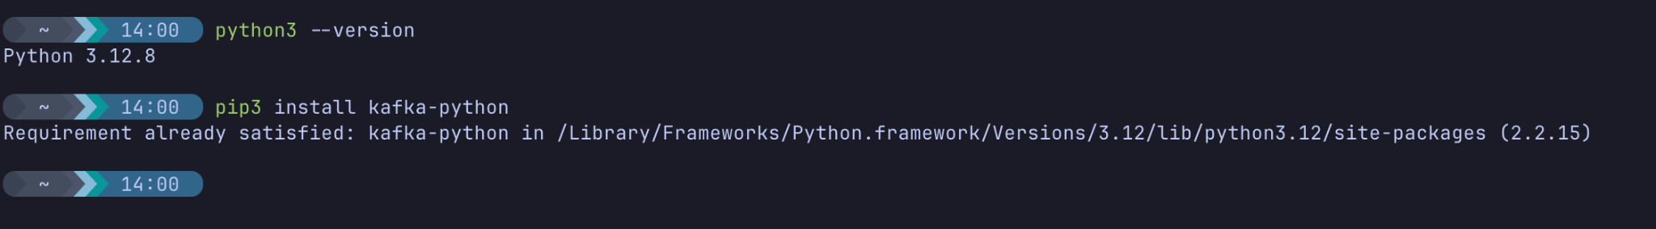
Authenticate to Redpanda Cloud
Connect your local rpk tool to your Serverless cluster:
1. Log in to your Cloud account:
rpk cloud login

2. Select your Serverless Cluster:
rpk cloud cluster select

3. Verify your connection:
rpk cluster info

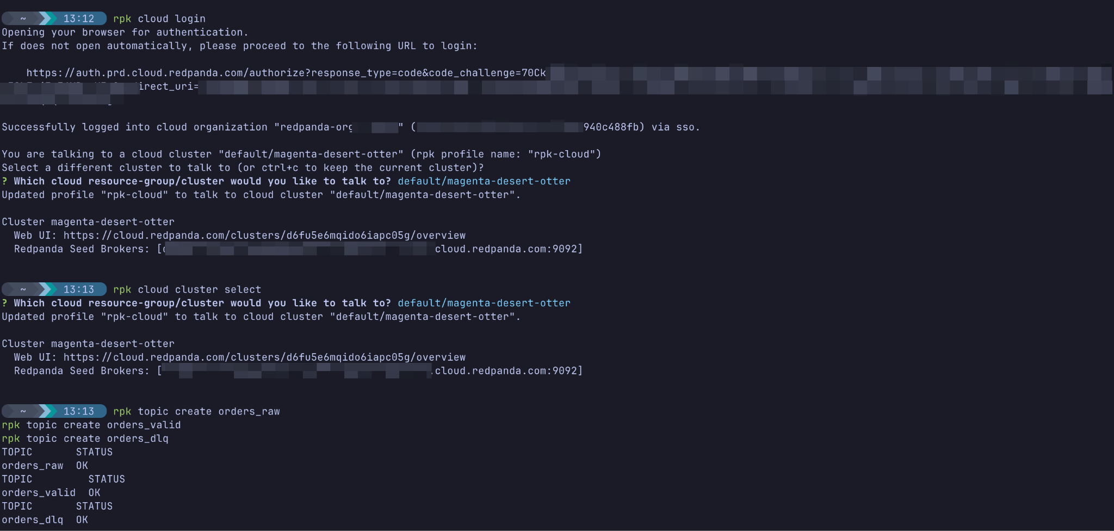

Retrieve Cloud Credentials
For the Python script in Part 2, you will need to authenticate securely. You can find these details in the Redpanda Cloud UI:
1. Create a User (if you haven't already in Lab 1):
- In the Redpanda Cloud UI, navigate to Security on the left sidebar.
- Click Users -> Create User.
- Create a user and securely save the username and password
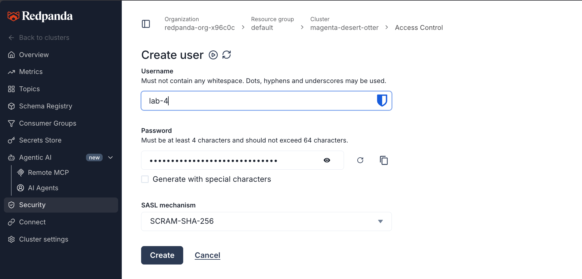
- Next, switch to the ACLs tab (still under Security) and click Create ACLs.
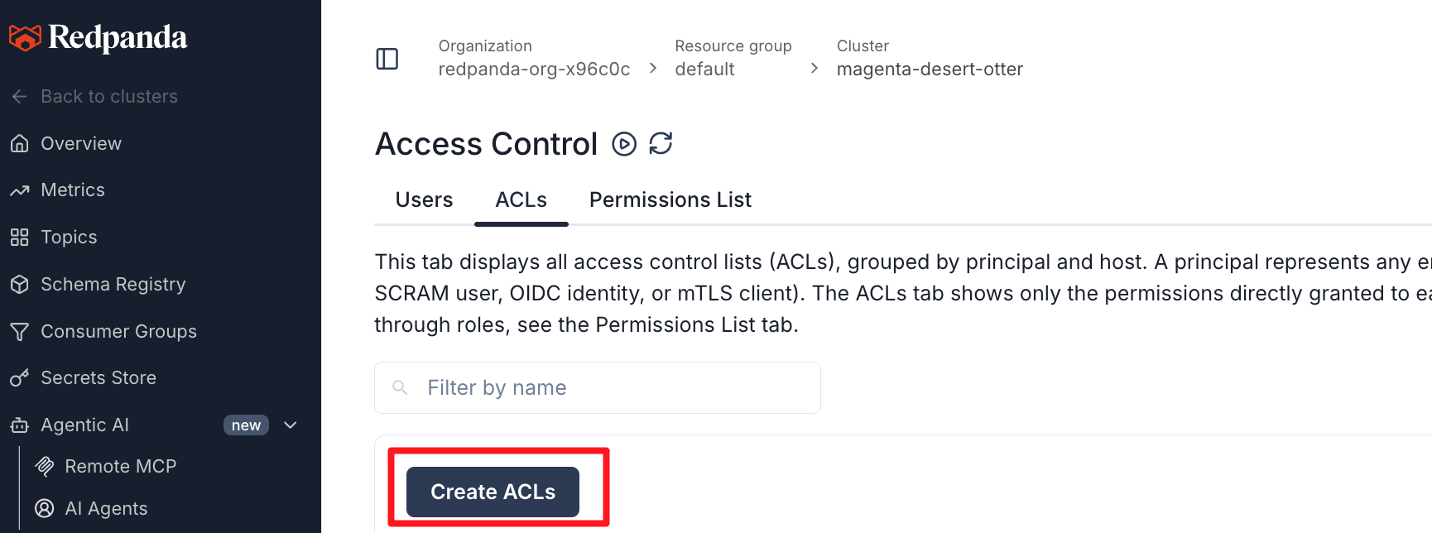
- In the User / principal field, enter the name of the user you just created (e.g., student).
- Click the Allow all operations button on the right side (this easily grants necessary access for lab testing).
- Click Create at the bottom to apply the permissions.
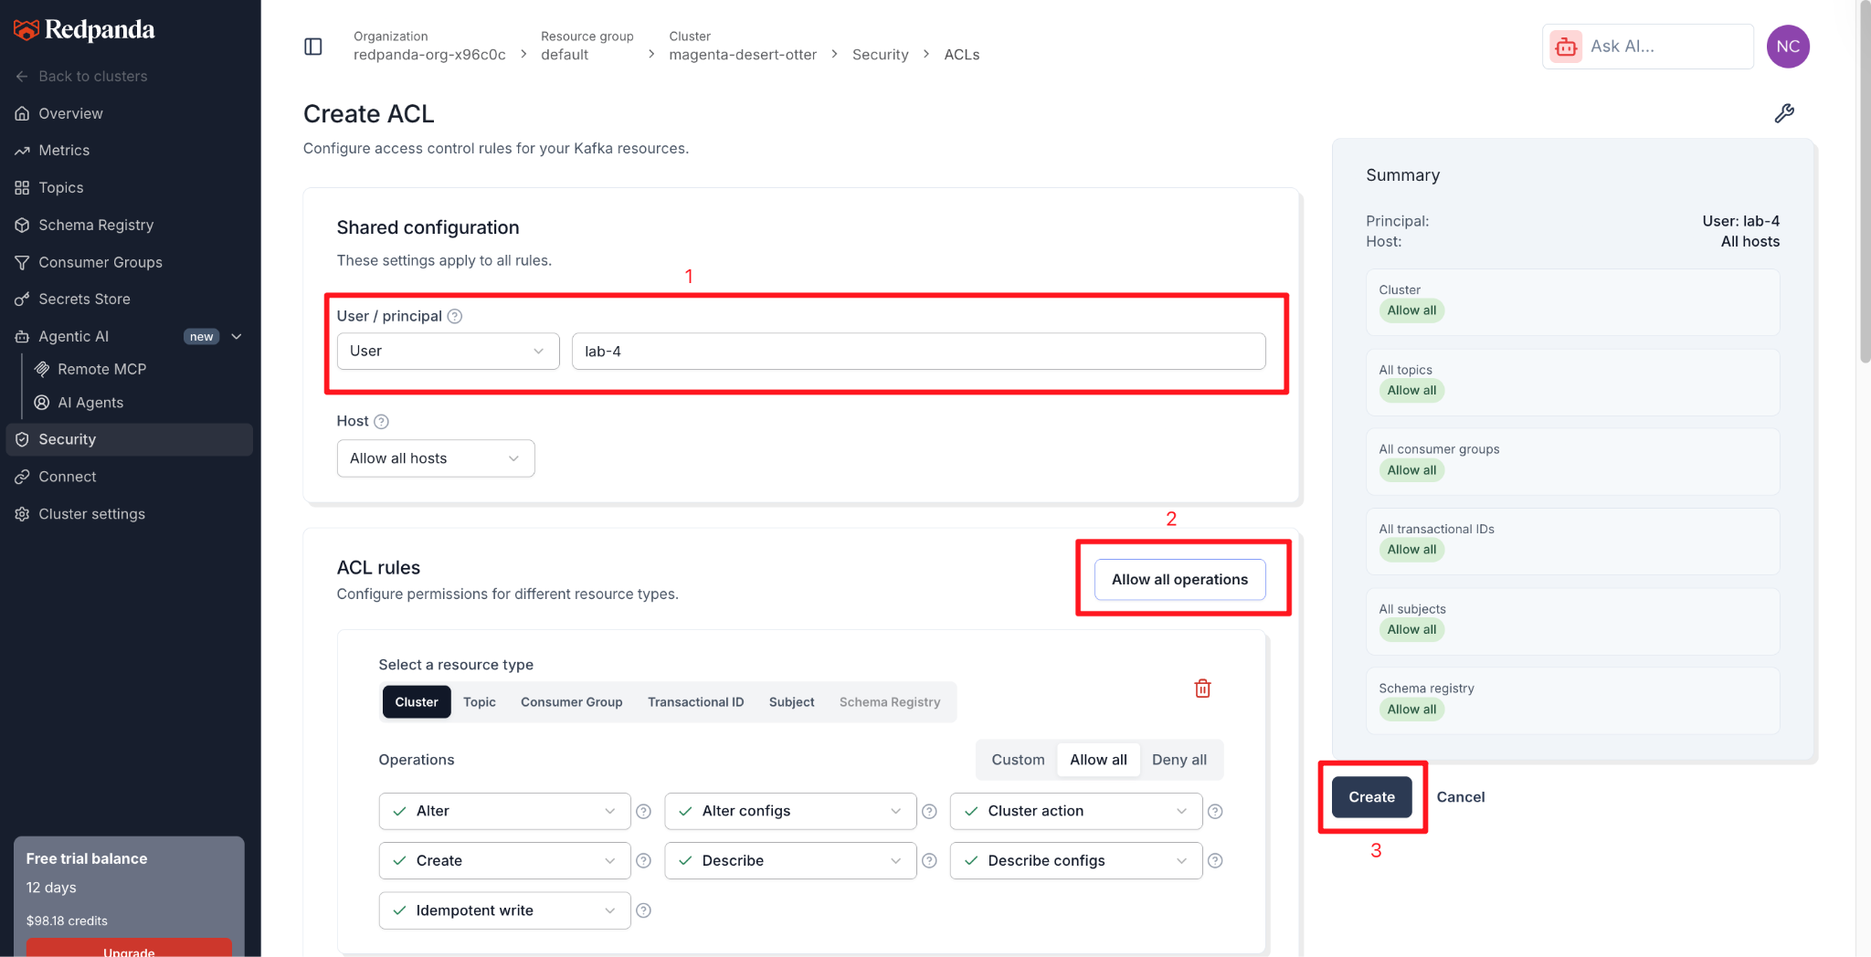
2. Find your Connection Details:
- Navigate to Overview on the left sidebar.
- Scroll down to the How to connect section.
- Click on the Kafka API tab (next to the CLI tab).
- Copy your Bootstrap server URL (it will look similar to d6fu5e6mqido6iapc05g.any.ap-south-1.mpx.prd.cloud.redpanda.com:9092).
- Notice the configuration values listed here: SASL mechanism (SCRAM) and Security protocol (SASL_SSL). We will explicitly use these in our Python code
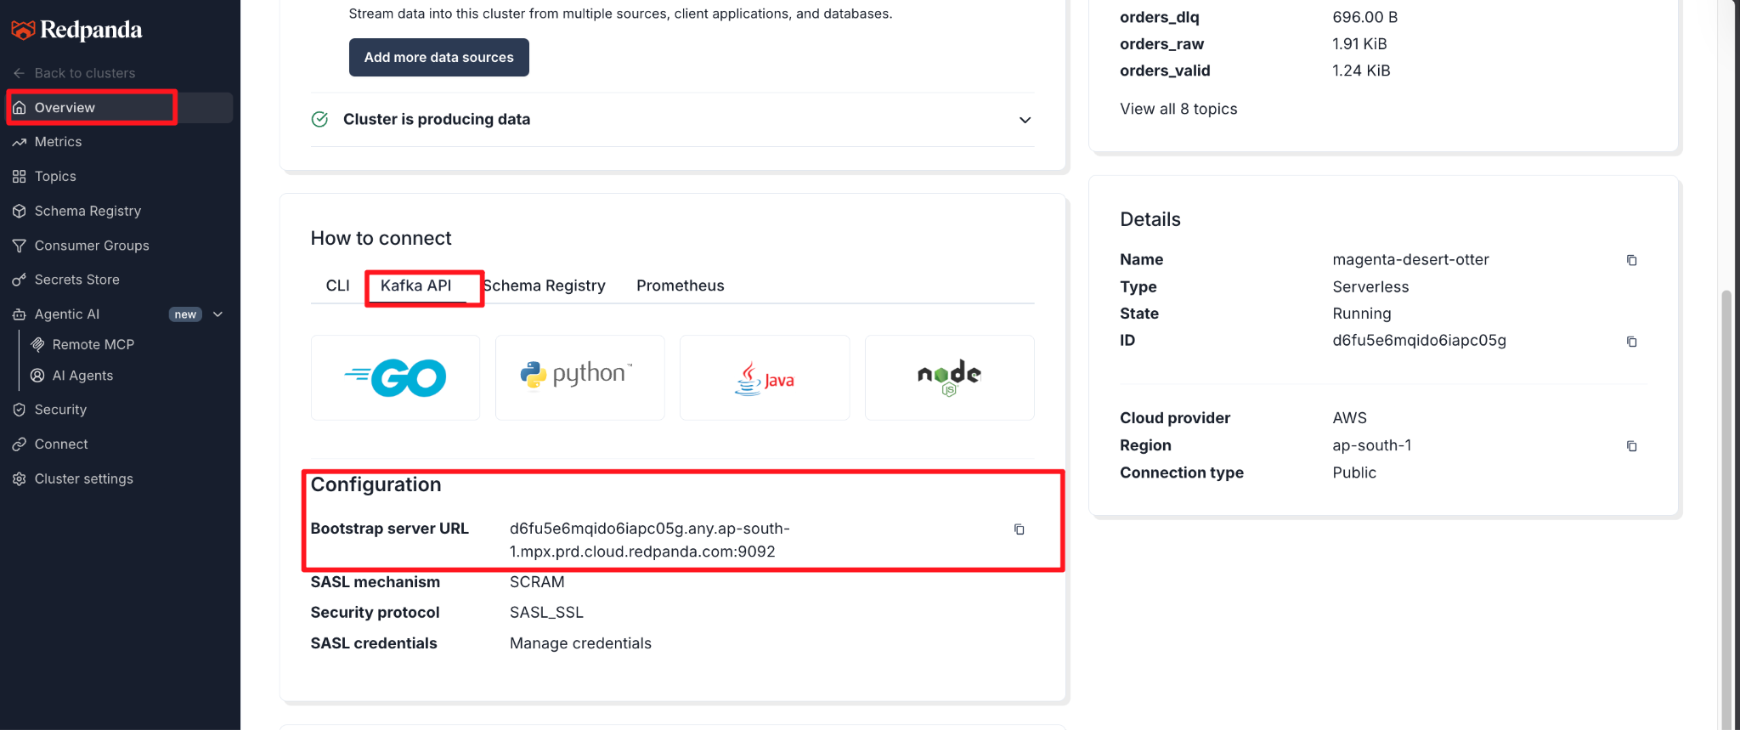

Part 1 — Pipeline Setup
We will create three topics representing stages of the pipeline directly in your Serverless cluster.

Step 1 — Create Pipeline Topics
rpk topic create orders_raw
rpk topic create orders_valid
rpk topic create orders_dlq

- orders_raw → incoming events
- orders_valid → successfully processed messages
- orders_dlq → failed or malformed events
Expected Output:
TOPIC STATUS
orders_raw OK
orders_valid OK
orders_dlq OK

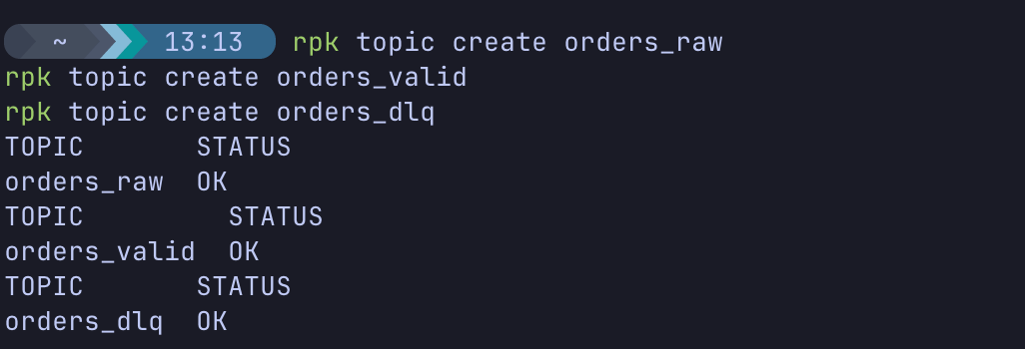

Step 2 — Inject Test Messages
Produce a mix of valid and invalid records into the raw topic:
rpk topic produce orders_raw

Type the following messages manually, pressing Enter after each line:
{"order_id":1,"amount":100}
{"order_id":2}
{"order_id":3,"amount":250}
invalid_json

(Press Ctrl+D to exit. The missing fields and invalid JSON will trigger failures in our consumer).
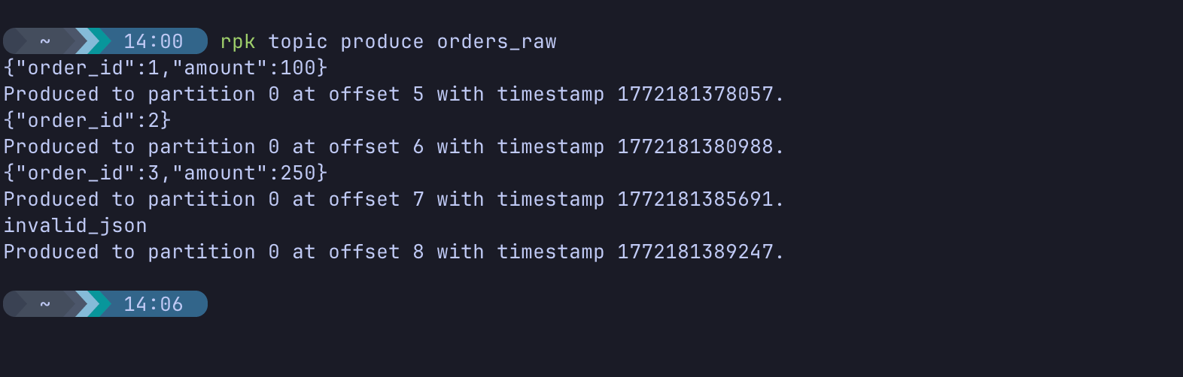

Part 2 — Consumer/Connector Simulation
Create a new Python file to act as our pipeline processor:
nano consumer_pipeline.py

Paste the following template. Remember to update the Serverless connection settings with the values you gathered in the Prerequisites!

from kafka import KafkaConsumer, KafkaProducer
import json
import time

BOOTSTRAP_SERVERS = 'd6j8spp19241bg3e6hi0.any.ap-south-1.mpx.prd.cloud.redpanda.com:9092'
USERNAME = 'kedar'
PASSWORD = 'TnwRnLfMHMoqyhoJprI0ysMEiAC2bX'

consumer = KafkaConsumer(
'orders_raw',
bootstrap_servers=[BOOTSTRAP_SERVERS],
security_protocol='SASL_SSL',
sasl_mechanism='SCRAM-SHA-256',
sasl_plain_username=USERNAME,
sasl_plain_password=PASSWORD,
auto_offset_reset='earliest',
enable_auto_commit=False, # IMPORTANT
group_id='orders-group-serverless'
)

producer = KafkaProducer(
bootstrap_servers=[BOOTSTRAP_SERVERS],
security_protocol='SASL_SSL',
sasl_mechanism='SCRAM-SHA-256',
sasl_plain_username=USERNAME,
sasl_plain_password=PASSWORD
)

MAX_RETRIES = 3

print("Consumer started. Listening for events...")

for msg in consumer:
value = msg.value
success = False

for attempt in range(1, MAX_RETRIES + 1):
try:
data = json.loads(value.decode())

if "order_id" not in data or "amount" not in data:
raise ValueError("Missing required fields")

producer.send('orders_valid', value=value)
producer.flush()

print(f"Processed valid order: {data['order_id']}")
success = True
break

except Exception as e:
print(f"Attempt {attempt} failed: {e}")
time.sleep(1)

if not success:
producer.send('orders_dlq', value=value)
producer.flush()
print("Sent to DLQ after 3 failed attempts")

# Commit offset only after handling
consumer.commit()
(Press Ctrl+X, then Y, then Enter to save and close).

What’s Happening?
- Because Serverless is secure by default, we use SASL_SSL and SCRAM-SHA-256 to authenticate.
- Consumer reads from orders_raw.
- Valid messages → sent to orders_valid.
- Invalid messages → retried locally.
- After 3 retries → routed to orders_dlq.

Part 3 — Retry Workflow
Run the consumer:
python3 consumer_pipeline.py

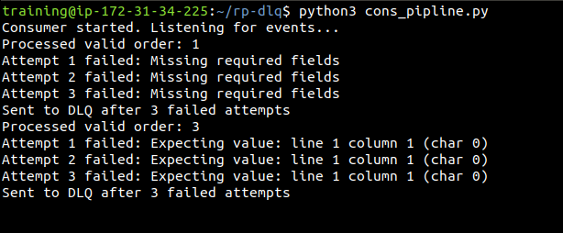

Observe terminal output.
- Valid records (order_id 1 and 3) are processed immediately.
- Invalid records (order_id 2 and invalid_json) are retried several times.
- Failed records are successfully routed to the DLQ, allowing the consumer to move on.

Part 4 — Failure Simulation

Scenario 1 — Malformed Messages
While your consumer is running, open a second terminal window, connect to your Serverless cluster, and produce more bad data:
rpk topic produce orders_raw

Enter:
{"order_id":4}
bad_data_here

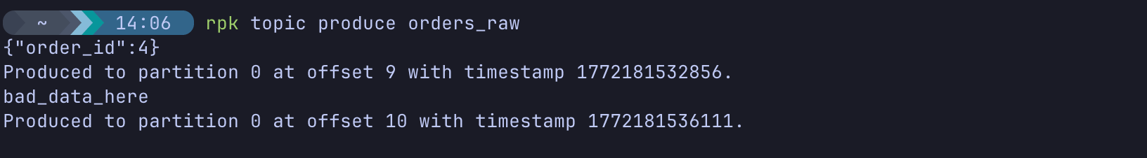
Observe behavior in the consumer terminal.
A poison message is one that consistently fails processing. DLQs prevent these from causing endless processing loops that halt your entire pipeline.

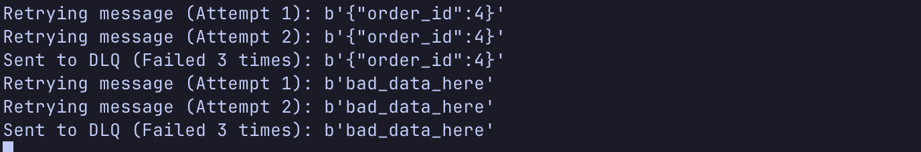

Scenario 2 — Consumer Crash & Restart
Go back to your consumer terminal and stop the script:
Ctrl + C
Restart it:
python3 consumer_pipeline.py

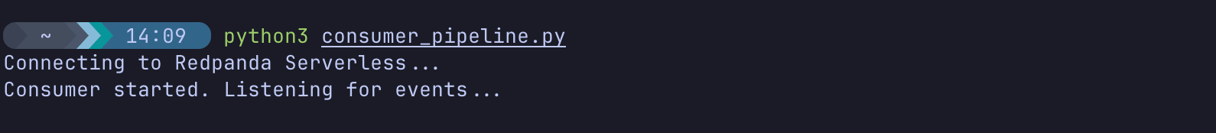

What You Should Observe:
The consumer resumes from the last committed offset. It does not re-process the messages it already successfully handled or moved to the DLQ.
This confirms:
- Serverless offset management works perfectly.
- No duplicate processing occurs.

Part 5 — Validation
Open a terminal and verify the final state of your cloud topics.
Check valid messages:
rpk topic consume orders_valid

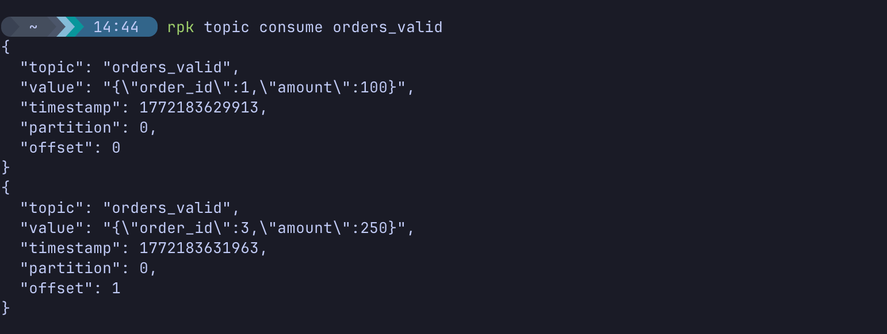
Check DLQ messages:
rpk topic consume orders_dlq

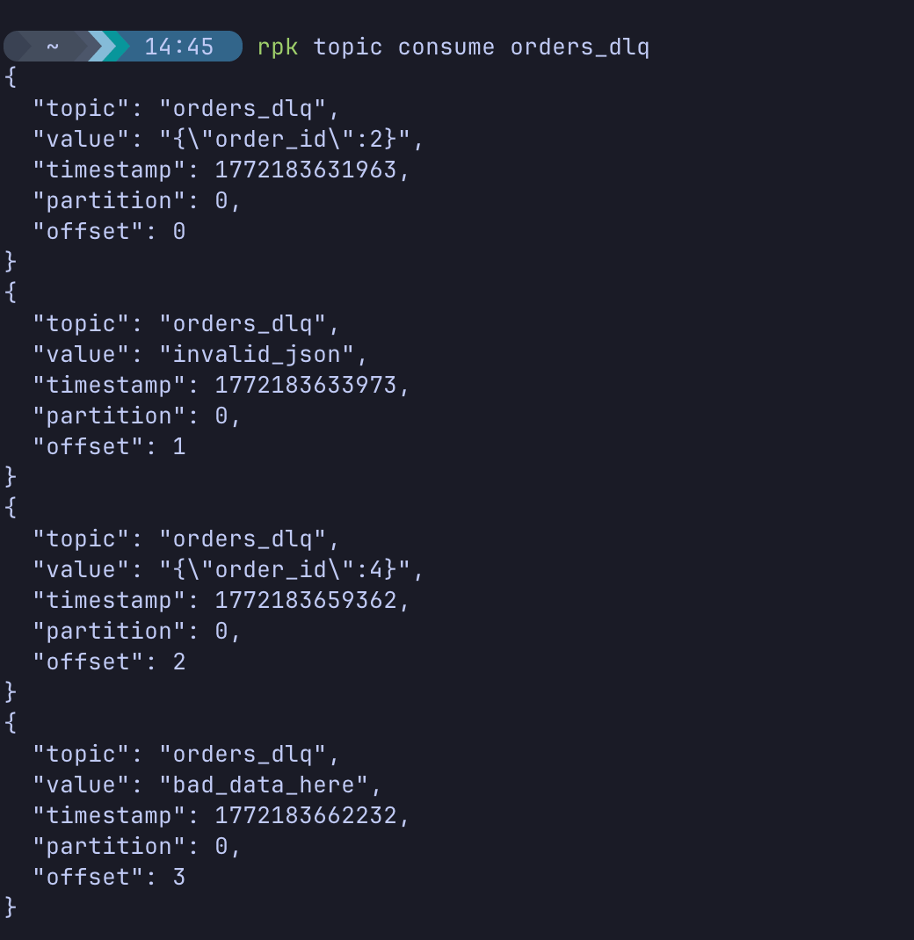

Expected outcome:
Valid records appear only in orders_valid. Invalid records appear only in orders_dlq.

Suggested Exercises
Exercise 1 — Change Retry Count
Modify MAX_RETRIES = 5 in your Python script.
Observe longer retry cycles and increased DLQ delays.
Exercise 2 — Remove DLQ Logic
Comment out the producer.send('orders_dlq', value=value) line and restart the consumer.
What happens? You will see infinite retry loops—illustrating exactly why DLQs are critical in production pipelines!

Knowledge Check
- Why do production pipelines use Dead Letter Queues?
- Answer: To isolate malformed or "poison" messages so they don't block the processing of healthy data.
- What happens if a poison message is retried indefinitely?
- Answer: The consumer gets stuck on that single offset, halting the entire partition's pipeline.
- How does Redpanda maintain consumer position after a restart?
- Answer: It stores the consumer group's committed offsets in an internal topic (__consumer_offsets).
- Why did we need SASL_SSL in this lab?
- Answer: Redpanda Serverless exposes endpoints securely over the public internet, requiring encryption (SSL/TLS) and authentication (SASL).

Troubleshooting

Symptom: No messages consumed
Solution: Verify the topic exists in your cloud environment:
rpk topic describe orders_raw

Symptom: Authentication Failed / SSL Handshake Error
Solution: Ensure you replaced the BOOTSTRAP_SERVERS, USERNAME, and PASSWORD in the Python script with your specific Redpanda Serverless cluster credentials. Verify your user has ACL permissions.

Symptom: Consumer restarts from the beginning every time
Solution: Ensure the group_id='orders-group-serverless' parameter is present in your Python consumer setup.

Next Steps
Clean up your Serverless environment by deleting the test topics:
rpk topic delete orders_raw orders_valid orders_dlq
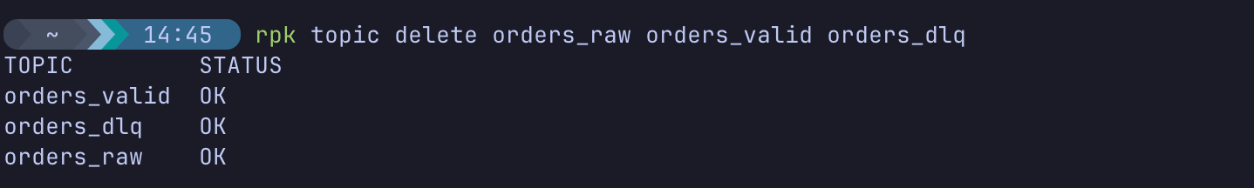

Conclusion
In this lab, you designed a production-ready resilient pipeline on Redpanda Serverless.
You learned how to:
- Connect applications securely to a managed cloud cluster.
- Implement retries and DLQ workflows.
- Handle malformed events safely.
- Prevent pipeline failures caused by poison messages.
- Observe offset recovery during consumer restarts.
These techniques are fundamental to operating reliable streaming architectures in real production environments.

